Report of the Interaction Workshop on Agriculture Development Strategy with Development Partner in Lumbini Province

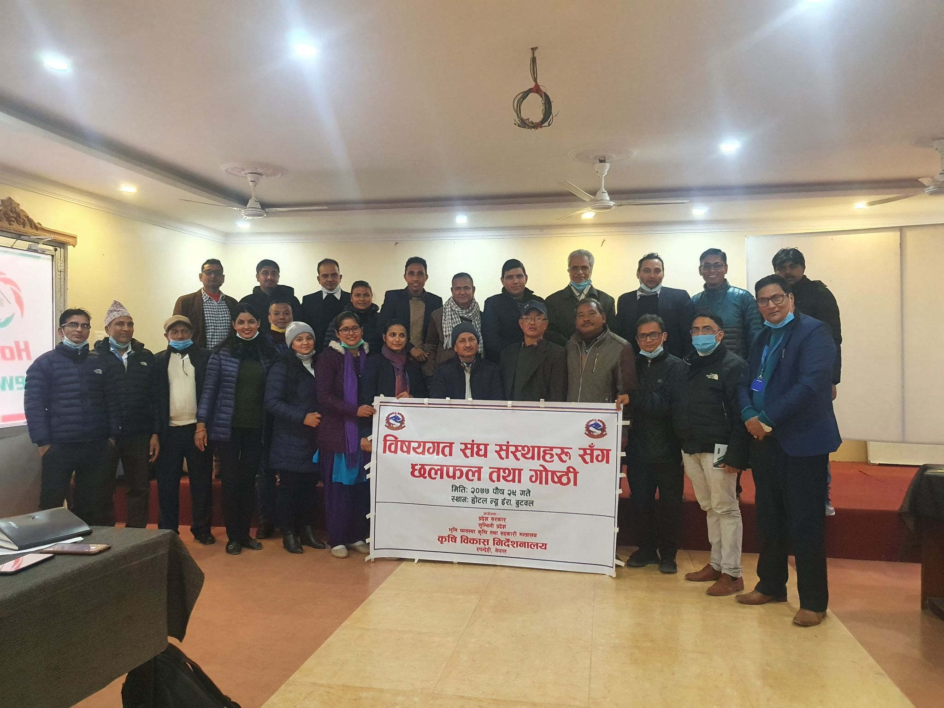

Organized by: DoAD, Lumbini Province
Venue: New Era Hotel , Butwal
Date: 13th Jan. 2020
Total Participants: 26
Duration: One day
Reported by: Dila Ram Bhandari (ADS Expert)

Agriculture Development Strategy (ADS) Interaction with Development Partner

1. Background:
The development partner in Nepal support on national agricultural policy improvement as well as community based programs such as food and nutrition security, improves livestock health, promotes production of nutrient-rich foods in household kitchen gardens, increases farmer’s access to credit and marketing opportunities and improves farmer’s livelihoods. The NGO/INGOs are independent of governments and are typically non-profit organization. The objective of NGO/INGOs are different based on their mandate and roles. The agriculture related NGO/INGOs focused on income generation through agricultural activities in rural, peri-urban and urban areas. Many Non-Governmental Organizations (NGOs) and Community Based Organizations (CBOs) provide education and training to farmers. Most of them in the district and municipality level work in partnership with Government institutions, private sectors and other social organizations. Some of the NGOs/INGOS working in Lumbini province have participated in the workshop organized by DoAD and had presented their activities carried out in the respective field.
This report provides an overview of sessions, presentations and discussions held during the ADS orientation and sharing of Development Partners’ activities. The workshop was the first meeting of this ADS to development partners. It took place at the Butwal headquarters of Lumbini province on 13th January 2021. The workshop was held for one day and was primarily focused on establish a strong relationship and sustainable partnership as well as identification of priority areas for better planning and the development of a partnership plan in the coming fiscal year. This workshop also provided an opportunity to bring together of several development partners for partnerships that are currently working in the province. So, a provincial level ADS implementation workshop with development partners (कृषि विकास रणनीति कार्यान्वयनका लागि बिषयगत संघ संस्थाहरु संग छलफल तथा कार्यशाला गोष्ठी) has been successfully conducted. The workshop objectives were;
2. Objectives of the workshop:
- To orient about ADS among government officials and development partners.
- To make greater understanding of various NGOs/INGOS’s program activities and initiatives in the province.
- To avoid duplication of resources and make proper utilization through mutual planning of program activities
- To make exchange of good agricultural practices and knowledge between government and development partners.
3. Workshop Proceedings
3.1 Opening Session
The workshop was opened by Yam Narayan Devkota, Director of the DoAD. Ms. Kamana Adhikari welcomed participants to share experiences and lessons learned on various activities in the field . She outlined how in many ways we are lagging behind in many areas and that we need to work better across different approaches in order to enhance agriculture development. In her welcome remarks she stressed the importance of strengthening of institutional partnership approach between government and development partner at palika level and provincial level.
3.2 Paper presentation session
The sharing workshop was attended by twenty six (Annex 1) participants from Government and development partners. The participants were from different provincial institutions such as Division chiefs of MoLMAC, Directorates (Both agriculture and livestock), development partners include : CIMMYT International Nepal, Unity for Sustainable Community Development, Peoples Development and Mobilization, KISSAN-2, Rural Economic Development Association, Heifer International, SUAAHARA, Rise Nepal, IDE International Nepal, United Nations Development Programs, LIBIRD, Agro Self Employment for Partnership (AESP), Environment Conservation and Community Development Center, Human Rights Development, Environment and Research Center. A total of 10 papers from DoAD, ADS expert and development partners were presented in the workshop. All the development partners they presented their program goal, vision, mission, objectives, budget, target groups, working area, beneficiaries, donner funding and coordination mechanism with palika and province level etc. Time allocation for slide presentations were to be a maximum of 15 minutes.
3.3 Discussion Session
In the discussion session 5 persons were raised various comments and suggestion to make ADS and other activities success in implementation. Discussion focused on the importance of the joint team working for planning, implementation and M&E of agricultural activities at palika level. However, It was highlighted that Development partners and the government do not have the same timeline for planning. They emphasized to work in coordination with green volunteers at ward level. They also said formation of technical working committee at palika level would be very useful. The discussion session was very viable and impressive with good suggestions from development partners for the commercialization of agriculture in the province.
3.4 Closing Session
Participant remarks:
Finally, the participants were also asked to provide their comments and suggestions about the overall of the workshop. Accordingly, the following points were pinpointed by the respondents.
- The involvement of the relevant stakeholders of agriculture was appreciated.
- The workshop has broaden knowledge and experience on the sharing of respective programs of concerned development partners.
- Both Government employ and development partners also had the opportunity to exchange information about the program activities.
- Continuous dialogue between partners is necessary
Chairperson remarks
The chairperson Yam Narayan Devkota delivered his closing remarks on various aspects of agriculture development programs including ADS, fifteenth plan and provincial periodic plan to be considered while planning of agricultural activities among government institutions, development partners and private sectors. DoAD is continuously building relationships with a broad range of development partners to ensure the greatest collective support reaches to the farming communities. He advised to make network of agricultural stakeholders including development partners in the chairmanship of District Development Committee at district level. This has been already initiated in Banke and Dang district. He also said that activities can be shared between development partners and us within the package of the program. This workshop has created conducive environment and enhanced for jointly planning, implementation and M & E of agricultural activities between government institutions and development partners in the coming days.

3.5 Key Outcomes of the workshop
The participants agreed on the following recommendations for their future work:

- The workshop provided a strong endorsement of the value of the development partners and the benefits from meeting face-to-face interaction.
- Both development partners and government resources can be made return-oriented through co-ordination.
- Documentation and exchange of beneficiary farmers list by both the development partner and the government offices will help reduce the duplication of resources.
- Effective and regular communication for better co-ordination.
- Collaboration and sharing of successes stories.
- Joint decision making on planning, implementation and M & E of program activities.
- Both government and development partners can be mutually benefited to achieve targeted programs by exchanging expertise and new technology.
- This type of sharing workshop needs to be carried out regularly between and among partners.
- Transfer of agricultural technologies to farmers are more effective when the government, non-governmental (NGO), and private sectors work in partnership.

Workshop Schedule (14.12.2020)

Day | Time | Activity | Responsible Person
Day 1 | Session I
 | 10-10:30 | Arrival and Registration, Inaguration | DoAD, Dayaram Bashyal
 | 10:30 - 10:45 | Opening Session  (Session Chair – Director, DoAD) | Yam Narayan Devkota
 |  | Guest: Director | Tulsi Ram Bhandari
 |  | Guest: Division chief | Shreedhar Gyawali
 | 10:45 – 11:00 | Welcome Remarks | Kamana Adhikary Senior Plant Protection Officer
 | 11:00 – 11:15 | Coffee Break | MoLMAC
 | 11:15 –15:15 | Presentation Session | Presenter
 | 11.15 – 11.45 | DoAD presentation | Kamana Adhikary
 | 11.45- 12.30 | ADS presentation | Dila Ram bhandari (PADSE)
 | 12.30- 12.45 | CIMMYT International , Nepal | Kedar Nepal
 | 12.45- 13.00 | KISSAN 2 | Khim Raj Regmi
 | 13.00- 13.15 | Rural Economic Development Association (REDA) | Lila Bahadur Karki
 | 13.15- 13.30 | Heifer International , Nepal | Prem Sambyu
 | 13.30- 13.45 | SUAAHRA, Nepal | Arjun shrestha
 | 13.45 – 14.00 | RISE, Nepal | Jit Bahadur Chaudhary
 | 14.00- 14.15 | United Nation Development Program (UNDP) | Sudeep Aryal
 | 14.15-14.30 | LIBIRD, Nepal | Bishnu dhakal
 | 14.30-14.45 | Environment Conservation and Community Development Center | Hari Khadka
 | 14.45-15.00 | Aro-Self Employment for Partnership (AESP) | Saroj Panthi
 | 15.00-15.15 | Human Rights, Environment and Development Campaign, and Research Center (HURED) | Damodar Gautam
 | 15:15 – 15.15 | Floor discussion | Dila Ram Bhandari
 | 15.15– 16.0 | Closing session
 | 16.00 – 16.10 | Remarks by participant | Jit Bahadur Chaudhary
 | 16.10 – 16:25 | Remarks by Chairperson | Yam Narayan Devkota

Presentation session

Directorate of Agriculture Development (DoAD)

Kamana Adhikari
Senior Plant Protection Officer

Introduction:
Directorate of Agriculture Development (DoAD) was established in 2075 Ashoj 25 at Buwal. It provides services to the farmers of the 12 districts of Lumbini province through eight Agriculture Knowledge Centres (AKC), an Agribusiness Promotion Support and Training Centre and four laboratories. DOAD supports and promotes commercialization, mechanization and modernization of agriculture in Lumbini province. It also has a major role of coordinating the work of different institutions involved in the development of agriculture in the province. Although, more than 2 fiscal years have already been passed with establishment of the federal system of the country, coordination among different institutions is still lagging behind. The institutions involved in the agriculture development sector are implementing their program activities without coordinating and collaborating of other concerned stakeholders/institutions. So in order to initiate the co-ordination activities, DOAD has approved workshop for the interaction of the different non-government institutions in the fiscal year 2077/78.

Discussion theme

Why coordination?
- Everyone has the same scope of work and purpose,
- The service recipient is the same,
- Objectives have to be achieved by complementing each other
- Prevent duplication of grants
- Since the areas of work have to be determined so that the works are not in both areas of the same nature,
- Since it is necessary to exchange information and experiences and learning of each other's work,
- Identify and evaluate the needs of a particular place and find out what responsibilities can be met by which body to fulfill the need to get the best results,
- Identify areas where cooperation and collaboration are needed for investment
- Bring equality in the technology sought by all sectors in the field where one is working.

How to Co-ordinate?
Co- ordination is a mean not the ends.

- In the phase of the program planning (By collaborating on the activities of the same program, by conducting complementary programs and by conducting different programs)
- In the phase of program implementation,
- In the phase of monitoring and evaluation.

How to Implement co-ordination process?
- Formulate and implement programs in conjunction with the informally prepared Agriculture Development Forum or network in the district,
- Make the programs so that functions of the same nature should not repeated from both sides,
- Maintain equality in the grant percentage given to the grant recipients,
- Inform each other about the details of the grantee or the beneficiary,
- Bringing similarities in technology when creating a special geography special program or informing each other about the effectiveness of demonstrations if there is a new technology.
- Inform each other about approved programs

DoAD programs for FY 2077/78

Production promotion programs

- Crop Special Mission Program (Garlic, Onion, Potato, Maize, Citrus Fruits)
- Road corridor vegetable and other crop development programs,
- Smart Agriculture Village Program,
- Contract farming,
- Land consolidation (Chaklabandi)
- Production based subsidy program,
- Subsidy for mushroom, bee, flower, crops etc.

Storage processing and marketing programs

- Construction of cold storage house,
- Support on processing, leveling and packaging of agricultural products,
- Establishment and operation of farmer's shop for agricultural products,
- Support for Honey mart and flower shop establishment,
- Support for construction of market structures,
- Support for Transportation purchase,
- Establishment of provincial outlet in Pokhara, Kathmandu and Surkhet,
- Promotion of branding of major agriculture commodity.

Information, technology expansion and coordination

- Demonstration of various technologies (including in office premises and farmers)
- Publication and distribution of booklets, leaflets etc.
- Bulk sms service
- Training in various subjects
- Establishment of Kisan Call Center
- Network formation and meeting between stakeholders working in agriculture
- Regular meetings and discussions with technicians working at the local level
- Collaboration with various NGOs

Areas of expectation

- Technology demonstration
- Training and development of skilled manpower
- Resource center development
- Continuity of coordination and cooperation on program formulation, implementation and monitoring

What is the result of coordination?
- Effective and efficient service flow
- To be easy in achieving the expected objectives
- Transformation of the agricultural sector
- Improving the living standards of farmers

Agriculture Development Strategy

A brief of Agriculture Development Strategy (2015-2035)

1.Vision | “A self-reliant, sustainable, competitive, and inclusive agriculture sector that drives economic growth and contributes to improved livelihoods and food and nutrition security leading to food sovereignty.”
2. Key elements of vision | 1. Self-reliance 2. Sustainability 3. Competitiveness 4. Inclusion 5. Economic Growth 6. Improved Livelihood 7. Food and Nutrition Security
3. Objectives | The objective of this Report is to formulate a 20-year agriculture strategic plan including a 10-year Action Plan and Roadmap and a rationale based on the assessment of the current and past performance of the agriculture sector.
4. Key Indicators | 1. Self- sufficient in food grains 2. Year round irrigation coverage 3. Soil organic matter 4. Degraded land 5. Forest cover 6. Agricultural land productivity (AGDP/ha) 7. Agribusiness as % GDP 8. Agriculture trade balance 9. Agricultural exports 10. Percent of farm land ownership by women or by or as joint ownership 11.Percent of farmers reached by agriculture programs 12. Average annual growth of AGDP 13. AGDP/Agricultural labour 14. Poverty in rural areas 15. Percent stunting (height for age) among under 5 children 16. Under weight (weight for age) among under 5 children 17. Wasting (weight for height) among under 5 children 18. Women in reproductive age with chronic energy deficiency (measured as low BMI)
5. Strategic Components of the ADS | 1. Governance 2. Productivity 3. Commercialization 4. Competitiveness
6. Donor agencies for ADS formulation | 13 Development partners (ADB, IFAD, EU, FAO, SDC, JICA, USAID, DANIDA, WFP, World Bank, DFID, AusAID, and UN Women)
5.Major Program activities | 1. Flagship programs  1.1 Food and Nutrition Security Program (FANUSEP)  1.2 Decentralized Science, Technology, and Education Program (DSTEP)  1.3 Value Chain Development Program (VADEP)  1.4 Innovation and Agro-entrepreneurship Program (INAGEP).  2. Core programs  3. Other programs
Targets (Over a 20-year period (2015-2035) | - Agricultural growth will rise from the current 3 percent to 6 percent per annum.  - Irrigation area expansion by 400 percent  - Soil organic matter improvement by 50 percent  - Degraded land reduced by 50 percent  - Agricultural land productivity expansion by 250 percent  - Women’s ownership in land increased from 10 to 50 percent  - Food grain self-sufficiency from a 5 percent deficit to 5 per cent surplus  - Agricultural export increased by 800 percent  - Agriculture labor returns increased by double  - Reduction of rural poverty from 35 per cent to 10 per cent
6. ADS Institutions | 1. National ADS Coordination Committee (NADSCC)  2.National ADS Implementation Committee (NADSIC)  3.National ADS Implementation Support Unit (NADSISU)  4. ADS Implementation Support Trust Fund ( ATF)
7. Total Budget | Total (10-year) Cost of the ADS Rs billion (501.8 ), and Yearly Cost Average Rs billion/year (50.2).

Technical Cooperation Facility to – Agriculture Development Strategy (ADS)

CARD | The CARD is expected to support GON in implementing the ADS through policy dialogue, budget support and capacity building measures. The objective of the CARD is to contribute to poverty reduction to food and nutrition security, to climate change resilience, to improve the competitiveness of the sector and to generate higher and more equitable incomes in rural areas of Nepal. The TCF is a complementary support to the larger CARD programme.
Objectives | The overall objective to “Help achieve the objectives of the Agriculture Development Strategy of Nepal
Budget support | The TCF is a complementary support to the larger CARD programme  Total amount of EU budget contribution EUR 40 000 000 of which  EUR 36 000 000 for budget support and  EUR. 4 000 000 for complementary support
ADS roll out support | 1. Develop and roll out a communications strategy  2. Governance and policies  3. Agricultural Planning  4. Monitoring and Evaluation  5. Human resources development  6. Sector budget support

Summary of Development Partner’s activities

1. Rural Illiteracy Society Education (RISE)
1. Goal | Bring changes to fulfill the rights of children and women on development and participation and increase access on resources in agriculture to women and assist women achieving their right.
2. Mission | -Distinct and measurable improvement in awareness and educational condition of poor, disadvantaged and marginalized families especially children and women who are working in agriculture.  -Knowledge and skills enhanced by increasing participation in every aspect of development and equal access on national and local resources.  -Uplift the physical, social, economic and educational status of rural life by utilizing the local resources.
3. Objectives | -Training the community group formation members for skills and capacity build-up to the better economic improvement.  -Providing the knowledge and education of women, children and other marginalized people for their right protection.  -Providing the technical support for improving the sustainable development and poverty alleviation related to agriculture.  -Improving the health, status of marginalized communities and disadvantaged groups.
4. Donor agency | Poverty Alleviation Fund(PAF), Fund Board
5.Program activities | Poverty alleviation, Social ,mobilization, income generation, capacity-build-up skill based training, Saving and credit program, COS mobilization-Agriculture based activities
6. Total Budget | NRS. 84,482,713.0
7. Name of the Working District in the province | Kapilvastu, Nawalparasi, Banke, Rupandehi
8. Name of the Working Palikas in the province | Kapilvastu Municipality., Banganga Municipality, Shivraj Municipality, Budhabhumi Municipality, Suddhodhan Rural municipality, Mayadevi Rural Municipality., Butwal Sub Metropolitan city, Sunwal Municipality
9. Beneficiaries of stakeholders and HHs | New Idea sharing, Usages of local resources, Coordination, Interpersonal relationship build up, Need identifying, assessment, Problem analysis, Action, economic growth, Healthy Behavour Development etc
10. Innovative technology to be shared | Sasto Solar Drier, Plant Propagation, Breeding, Business planning. Level of economic status grading system through checklist, used of agriculture tools such as develop tunnel, IPM, Orgnic Fertilizer.
Others | NGOs, Government, Community Organization (COs) and Private sectors should action jointly.
2. Heifer International

1. Goal | Improved Global Sustainable Livelihoods
2. Mission | To work with communities to end hunger and poverty and care for the earth.
3. Donor agency | People of America
4.Major Program activities | 1.Institutional empowerment of small farmers  2.Enterprise Development Project in partnership with the local level  3.Modern abattoir construction  4.Community-led goat breeding improvement plan  5. Program on Goat, Dairy, Vegetables, Back Yard Poultry
5. Total Budget | NPR. 380,055,948.0
6.Implementing Partnership in the province | REDA, Tansen Municipality,
7. Name of the Working District in the province | Palpa, Rupandehi, Kapilvastu, Gulmi, Arghakhanchi, Dang, Pyauthan, Salyan, Banke, Bardiya
8. Name of the Working Palikas in the province | 27 Palikas (Rapti Sonari, Baijnath, Kohalpur (Banke), Gulriya, Bansgadi, Badaiyatal (Bardiya), Lamahi, Ghorahi (Dang), Tribeni (Salyan), Sworgdhwari, Sarumarani (Pyauthan), Sitganga (Arghakhanchi), Sainamaina, Kanchan (Rupandehi), Banganga (Kapilvastu), Resunga, Dhurkot, Malika, Isma, Madane, Musikot (Gulmi), Tansen, Rampur, Bagnaskali, Rainadevi, Nisdi, Purbakhola (Palpa)
9. Beneficiaries of stakeholders and HHs | 75,785 HH
10. Innovative technology to be shared | Access to finance to Cooperatives, Community Initiatives for Genetic Improvement (CIGIC), Cooperative as Business Hub, Collective marketing of agricultural commodities through Coops

3. Suaahara-II Integrated nutrition project. (Managed by Helen Keller International)

1. Goal | Improved and sustained nutritional status among woman and children of 42 districts of Nepal
2. Mission | Improving the health and nutrition status of women and children who fall within the 1,000 days period, from conception until a child reaches 24 months of age.
3. Objectives | - Promote key Maternal, Infant and Young Child Nutrition (MIYCN) practices through an intensive behavior change strategy, including interpersonal communication activities, radio programs, and the use of mobile technology at the community level.  - Expand coverage of the community-based integrated management of newborn and childhood illness program and strengthen growth monitoring and promotion at outreach clinics and health facilities.  - Enhance clean water, sanitation, and hygiene conditions of household facilities and establish private sector linkages to promote WASH technologies.  - Improve consumption of nutritious food through increased production, improved post-harvest storage, and processing diverse nutritious food, especially for women farmers from disadvantaged groups.  - Strengthen coordination on health and nutrition between government and other stakeholders through the Food Security and Nutrition Coordination Committee, Nepal Nutrition Group, Nutrition Technical Committee, Safe Motherhood sub- committee, Family Planning Subcommittee, and Reproductive Health Coordination Committee.  - Strengthen the technical, managerial, operational capacity of health and non-health sector stakeholders at the district and Village Development Committee (VDC) levels to enhance MSNP implementation.
4. Donor agency | USAID Nepal
5.Program activities | - Reduce stunting, underweight, and wasting prevalence among children under five in 42 target districts.  - Improve household health and nutrition behaviors.  - Increase use of quality maternal, newborn, and child health services; family planning services.  - Improve water, sanitation and hygiene behavior and practices.  - Increased consumption of diverse and nutritious foods by women and their families.  - Improve the food security of households.  - Transfer of key nutrition and health services in 15 Suaahara districts to GON management as appropriate.
6. Total Budget | 103,094,195 Nrs. F/Y 2077/78 (12 districts of Lumbini province), Not included the operation budget of District based NGOs.
7. Name of the Working District in the province | Nawalparashi-West, Rupandehi, Palpa, Kapilbastu, Gulmi, Arghakhanchi, Dang, Pyuthan, Rolpa, East Rukum, Banke, Bardiya
8. Implementing Partnership in the province | District and community level programs are implemented through local District based NGO.  1. Lumbini Social Development Center (LSDC) – Argakhanchi  2. Bheri Environmental Excellence Group (GROUP) – Banke  3. Jana Jagaran Mahila Sangh (JJMS) - Bardiya  4. Backward Society Education (BASE) – Dang  5. Integrated Rural Development Society (IRDS) – Gulmi  6. Kalika Self Reliance Social Center (NEPAL) – Kapilvastu  7. Backwardness Eradication Society (BES) – Nawalparasi  8. Backwardness Eradication Society (BES) – Palpa  9. Mallarani Rural Development Concern Center (MRDCC) Pyuthan  10. Rural Development & Awareness Society Nepal (RUDAS-Nepal – Rolpa  11. Rukumeli Sociaety Deevlopment Center (RSDC) - East Rukum
9. Name of the working Palikas in the province | All 109 palikas
10. Beneficiaries ( stakeholders and HHs) | 1.5 million beneficiaries from 42 districts ( 1000 days HH of province, adolescents, disadvantage groups)  Stakeholders: GoN- MoHP, Province, district and palika level multisector nutrition and food security committees.  MoSD, MoLMAC, Health, Agriculture and Livestock directorate.  DCC, Health Office, AKC, LHBK, Municipalities, Rural Municipalities, Ward, Health Facility, NGOs, Health worker, FCHVs, Agri/Livestock extension workers, Local private service providers
11. Innovative technology to be shared | Increase access of 1000 day households in nutrient dense diversified foods through homestead food production program as nutrition sensitive agriculture intervention
4. Knowledge-based Integrated Sustainable Agriculture in Nepal (KISAN) II
1. Goal | Increase resilience, inclusiveness, and sustainability of income growth in the Feed the Future Zone of Influence.
2. Mission | - Contribute to the objectives of the Government of Nepal’s Agriculture Development Strategy (ADS) and the U.S. Government’s Feed the Future Initiative.  - Facilitate systemic changes in the agricultural sector including: (1) greater climate-smart intensification of staple crops and diversification into higher value commodities; (2) strengthening of local market systems to support more competitive and resilient value chains and agricultural related businesses ; and (3) improving the enabling environment for agricultural and market systems development.
Approach | KISAN II is focusing on market systems and private-sector actors, however, recognizing that social and geographic contexts and barriers can create an uneven playing field for some groups, KISAN II is employing a “push-pull” approach to its outreach and engagement with beneficiaries. Push strategies help poor farmers and individuals build the capacity to participate in intensification, diversification, and value addition activities. Pull strategies increase the demand for smallholder production, labour, and related goods and services and improve the affordability and accessibility of skills, resources, inputs, and supporting services needed to participate in competitive markets. KISAN II is tailoring its approach to empower and graduate farming households into more productive, reliable, and lucrative agricultural enterprises evolving from vulnerable to developing, to commercially minded, and finally to competitive household agricultural enterprises.  KISAN II is including a Partnership and Innovation Fund (PIF), including a grants program, through which the project buy down the risk for lead firms to upgrade market strategies, create mutually beneficial contract farming and out grower schemes, and catalyze the involvement of women and disadvantaged groups through push interventions, complemented by a focus on market pull in key commodity supply chains.
3. Objectives | - Improve the productivity of selected agricultural market systems.  - Strengthen competitiveness, resilience, and inclusiveness of selected agricultural market systems.  - Strengthen the enabling environment of selected agricultural market systems.  - Enable vulnerable communities to act on business opportunities within selected market systems.  - Apply Collaboration, Learning, and Adaptation to market systems development.
4. Consortium Partners: | Prime: Winrock International; Subcontractors: CEAPRED, DEPROSC, Siddharth Inc, Digital Green, Overseas Strategic Consulting Ltd (OSC)
5. Donor agency | USAID
6.Project activities | - Increase adoption of profitable, productivity-enhancing, and climate smart technologies.  - Strengthen lead firms and other SMEs to support selected market systems.  - Enhance financial services markets and infrastructure that serve selected market systems.  - Build capacity for GON policies and regulation to support market systems development.  - Enhance literacy and business development skills
7. Total Budget | Total project budget $32.7 million for KISAN II working districts in Bagmati, Lumbini, Karnali and Sudurpaschim province for the period of July 12, 2017 to July 11, 2022.
8.Implementation Partnership in the province | Private sector partners in Lumbini Province - 58  - Agrovets - 25  - Cooperatives - 18  - Goat Farms - 2  - Rice Mills - 7  - Traders - 6
9. Name of the Working District in the province | Kapilbastu, Palpa, Arghakhanchi, Gulmi, Pyuthan, Dang, Rolpa, Rukum East, Banke and Bardiya.
10. Name of the Working Palikas in the province | Kapilvastu: Baganga,Maharjgunj, Kapilvastu, Shivaraj, Buddhabhumi, Vijayanagar, Mayadevi, Suddhodhan, Yasodhara  Palpa: Tansen, Rampur, Rambha, Baganaskali, Machhagadhi, Tinau, Ribdikot, Rainadevi-chhahara  Gulmi: Satyawati, Chandrakot, Gulmidarbar, Isma, Dhurkot, Madane  Arghakhanchi: Sandhikharka, Bumikasthan, Sitganga, Malarani, Padeni, Chhatradev  Dang: Ghorahi, Tulsipur, Dangisharan, Lamahi, Gadhwa, Rajpur, Babai, Shantinagar.  Pyuthan: Pyuthan, Swargadwari, Mandavi, Jhimruk, Gaumukhi.  Rolpa: Runtigadhi, Rolpa, Triveni, Madi, Gangadev, Thabang  Rukum East: Sisne, Putha-Uttarganga, Bhume  Banke: Nepalgunj, Rapti-Sonari, Baijanath, Khajura, Janaki, Duduwa, Kohalpur, Narainapur  Bardiya: Gulariya, Barbardiya, Thakurbaba, Madhuvan, Bansgadi, Rajapur, Badaiyatal, Geruwa
11. Beneficiary | Direct beneficiary (Farming households) - 82,340  Indirect beneficiaries (Private firms and Cooperatives) - 58
12. Innovative technology to be shared | Vegetables - Introduction of high yielding varieties, micro Garden, plastic mulch, use of transplanter, Zero energy cooling chamber, and other good agriculture practices  Goat - Breed improvement through artificial insemination  Cereals - Line sowing, balanced dose fertilizer application, varietal demonstration; value addition in rice by silky & whitener machine.

5. Local initiatives for Biodiversity, Research and Development (LI-BIRD)
1. Goal | Contribute to strengthening resilient livelihood systems through improving ecosystem services, and ensuring food, nutrition and income security of smallholder farmers, especially women and youths.
2. Mission | LI-BIRD’s mission is to diversify choices and secure livelihoods of smallholder farmers through innovative approaches to research and development in agriculture, biodiversity, and natural resources.
3. Objectives | - To improve livelihood of small holder farmers  - To develop climate and disaster resilient capacity of communities.  - Strengthen grassroots organization  - Integrate GESI on agriculture.
4. Donor agency | 1. Livelihood Resilience Enhancement Project (LREP)  Donor Agency : NORAD through Development Fund, Norway  2. Improving Livelihood of poor and marginalized farmer through agriculture value chain approach (ILM/DCA)  Donor: Dan’s Church Aid  3. Economic response to Covid 19. Securing Family Farming  Donor: GIZ
5.Program activities | - Food and Nutrition Security :  - Cereal crop Seed distribution of new Varieties  - Home Garden Improvement and Trainings.  - Small Livestock promotion activities (soft loan at 6% per annum through cooperative, insurance, trainings etc)  - Seed production and sale through CSB  - Climate Resilience and Disaster Risk Reduction  - Climate Adaptive Village  - Climate smart technology promotion (Recharge pond, Rice duck farming, Solar irrigation etc)  - Ecological farming village  - Community Seed Bank promotion  - Income Generation  - Vegetable production for sale  - Livestock rearing support  - Market promotion activities (Market promotion committee formation, Weekly market)  - Strengthening local institutions (Cooperative, Collection centers,  - Local Partner, Palika Staff, lead farmers)  - GESI  - Women friendly tools and technology promotion.
6. Total Budget | NPR 1.7 million
7.Partnership institutions in the province | Tharu Women Upliftment Center (TWUC), Guleriya  Seto Gurans , Butwal  Janajagaran Samaj (JJS), Nepalgunj  Sahakarmi Samaj (Kohalpur, Banke)
8. Name of the Working District in the province | Banke, Bardiya,Dang, Rupendehi
9. Name of the Working Palikas in the province | Banke – Nepalgunj Sub-Metropolitan City  Bardiya – Barbardiya Municipality, Guleriya Municipality, Badhaiyatal Rural Municipality, Bansgadhi Municipality  Dang- Ghorahi Municipality  Rupendehi – Butwan Sub- Metropolitan City
10. Beneficiaries (stakeholders and HHs) | - 6 Cooperatives,  - 148 Farmers group  - 5100 HH  - Muktakamaiya, Landless, Marginal communities  - Migrant Returnee, Youths
11. Innovative technology to be shared | Food Security – Home Garden  Climate Resilience – Solar Irrigation, Recharge pond, Rice duck farming, Community seed bank, Mixed cropping, Botanical Pesticide, Cattle shed improvement.  Income generation: Vegetable production on small land

6. Peoples Development and Mobilization Centre (PDMC)- Nepal
1. Goal | This organization will assist to bring poor, disadvantages, downtrodden and marginalized classes into the main stream of the nation by including their knowledge, skill and idea through socialization so as to ease their living.
2. Mission | This organization will endear our too built up a socially and economically empowered and self by producing competent human resource through social empowerment and income generation program in order to mobilize local means and resources
3. Objectives | - This organization aims to educate adult group by the provision of action oriented adult education.  - It makes an effort to conduct child education for children before going to school.  - It strives to conduct girl's education for deprived girls.  - Owing to the deforestation, landslides occur, water fountains are gating dry. Forest areas are diminishing. So, it hill sun programs like a forestation, jungle protection and public awareness in order to present such disasters calamities.  - It will manage different kinds of vocational trainings so as to increase per capita income and promote skills like handicrafts, knitting etc, especially to utilize/exploit the local resource such as bamboos.  - It will provision various types of technical training like farming, animal keeping, bee keeping, fruit farming, and tailoring as well as other types to build up capacity.  - It will lunch public awareness programs about health hazards.  - It will trigger development works such as road and bridge construction, drinking water provision, irrigation etc for the public living standard.  - Either it will provision or beg the charity from other organization for disaster or foods sicken people.
4. Donor agency | iDE Nepal, Heifer International Nepal, Tinau Rural Municipality, Nisdi Rural Municipality
5.Program activities | Agriculture, livelihood
6. Name of the Working District in the province | Palpa
7. Name of the Working Palikas in the province | All local level of Palpa district
10. Beneficiaries ( stakeholders and HHs) | Almost 5000 HH has been directly affected by the accomplished projects till date

5. CIMMYT (Nepal Seed and Fertilizer Project) / NSAF

1. Goal of the project | The goal of the project is to build competitive and synergistic seed and fertilizer systems for inclusive and sustainable growth in agricultural productivity, business development and income generation in Nepal.
2. Objectives | - Enhancing the capacity and role of public private sectors and community sectors in the seed and fertilizer value chains through the provision of technical and business development services  - Improving private sectors access to inbred lines and research knowledge from national and international research institutions.  - Enhancing public-private partnerships and coordination by establishing a tripartite research forum and a seed and fertilizer information system at the national level
3. Donor agency | United State Agency for International Development (USAID)
4.Program activities | - Testing and validation of market ready products/germplasms of maize, lentil, onion and tomato, and registration of new varieties. GATE-Nepal has already developed proposal for the zinc enriched white maize variety and is in a process of registration. Other companies are also planning to prepare and submit their proposal for registration at NSB.  - Promotion of pipeline/new varieties of NARC and NSAF allocated varieties through demonstrations, farmers’ field day (FFD), minikit, radio jingles, meetings, leaflets, seed fair, brand promotion through digital tools, attractive packaging, poster/flayers and rewards/awards.  - Technical and financial support for hybrid/OP seed production and distribution (sales), including biofortified crops  - Capacity development of public and private sectors, including seed producers, technicians, agrovets, seed companies, university/college people, and adoption of good seed management practices, including crop insurance, finance digital communication, branding, etc  - Parental lines maintenance and seed increase,  - Interaction meetings with local government, grain producers and agrovets.  - Commercialization activities of maize seed and linkages with output/end markets  - Analyze and strengthen value chains of NSAF working crops  - Validation and promotion of integrated soil fertility management practices  - Developing new and domain specific fertilizer recommendations for target crops.  - Developing a roadmap for balanced soil fertility management in Nepal  - Developing a digital soil map for Nepal.  - Support seed partners by assigning project staff and allocating budget to establish a viable seed business in the province  - Equipment support to partners to enhance seed quality and quantity in the province  - Collaboration with partners to promote seed systems for last miles by engaging women and disadvantaged groups  - Strengthen strategic partnership among value chain actors for scaling and commercialization of NSAF validated technologies.  - Joint monitoring and evaluation (internal and external)
5. Total Budget | Total estimated operational budget from Oct 2020 to Sep 2021 is US$ 97,106
6.Partnership institutions in the province | NARC:  - Agricultural Research Directorate, Khajura, Banke  - Grain Legumes Research Program, Khajura, Banke  Seed Companies:  - Global Agri-Tech (GATE) Nepal Pvt. Ltd, Banke;  - Gorkha Seed Company Pvt. Ltd., Kathmandu/Dang;  - Nepal Agro Seeds and Inputs Company (NASIC) Pvt. Ltd., Dang/Chitwan;  - SEAN Seed Service Centre, Kathmandu/Salyan;  - Lumbini Seed Company Pvt. Ltd., Rupandehi;  - Seed Entrepreneurs’ Association of Nepal (SEAN), Kathmandu/SEAN Province and District Level Coordination Committees  Cooperatives:  - Suryodaya Farmers’ Multipurpose Cooperative Ltd., Dang;  - Naya Srijansil Samajik Uddhyamik Mahila Cooperative Ltd., Banke  Feed Mills: Shreenagar Feed Mill, Rupandehi  AKC: Kapilvastu, Banke, Bardiya  IALDO: Bardiya  PMAMP: Dang, Kapilvastu  NARC/RARS-Khajura, Banke  NARC/NGLP-Khajura, Banke
7. Name of the Working District in the province | Kapilvastu, Arghakhanchi, Gulmi, Palpa, Puthan, East-Rukum, Rolpa, Dang, Bannke, Bardiya
8. Name of the Working Palikas in the province | - Kapilbastu: Kapilbastu, Banganga muni, Shivpur, Bijayanagar, Buddhabhumi municipality, Yasodhara , Suddhodhan , Shivraj Municipality  - Agrhakhanchi: Bhumukasthan, Sandhikharga, Pandeni, Arghkhanchi, chatradev, Malarani  - Pyuthan: Sarumarani, Mallarani, Mandevi, Airawati  - Palpa: Tansen MCP, Pakluwa, Rampur MCP, Ribdikot, Bagnaskali, Mathagadh  - Banke: Duduwa, Khajura, Kohalpur, Raptisonari, Janaki, Bijanath, Nepalgunj NP  - Bardiya: Gulariya, Madhuban MP, Bansgadi MP Badaiyataal, Barbardiya, Rajapur MP,Thakurbaba NP  - Dang: Ghorahai SMP, Tulsipur NP, Dangisaran Lamahai MCP, Rapti MCP, Banglachuli VDP, Gadawa VDP, Rajpur VDP  - Rukum: Musikot (west rukum), Sanibheri RM-9
9. Beneficiaries (stakeholders and HHs) | This project has already reach with approximately 60,000 household in the province
10. Innovative technology to be shared | - New varieties and best management practices on seed and fertilizer, including 4 R (right source, right amount, right time and right method) of fertilizer application in rice, maize and vegetables  - Support private seed partners to establish/strengthen their R&D for the development and deployment of new products and crop management  - Seed production and promotion of biofortified crops including Zinc enriched maize and Iron and Zinc enriched lentil  - Initiation and scaling up of hybrid maize seed production and marketing in the province in collaboration with public and private partners.  - Leading and closely working with partners in the province to fight back the Fall Armyworm (FAW), including awareness campaigns, capacity development of partners and promotion of IPM packages for FAW.  - Sharing the prospects and key lessons in access to finance and seed crop insurance to partners in the province  - Promotion of hybrid seed production technology in maize and commercializing domestic maize hybrids by engaging migrants  - Brand building to partners including designing of attractive seed package, company webpages and development of branded items to promote partners’ products  - Link partners with the nationally developed Digitally Enabled Seed Information System (DESIS)  - Support partners in adopting innovative marketing tools including, buyers/producers loyalty programs, customized on farm varietal demonstrations and enhance linkages with end markets/feed mills….  - Development of customized radio jingles and other seed promotion and extension methods to augment the rapid diffusion of recently released varieties  - Piloting a digital soil map for local decision making; soil fertility management and new project design for agriculture development  - Testing and piloting blended fertilizers for rice and maize

6. Rural Economic Development Association (REDA)
1.Vision | Local communities will have increased access to the resources and associations available at various levels, which will result in stronger organized communities that will continue to grow in a state of self-reliance.
2. Mission | Facilitate the community for continuous increase in the state of self-reliance through identification and sustainable mobilization of available economic, physical, human and natural resources at various levels.
3. Objectives | 1.To commercilize of cash crop and livestock through market promotion  2. To transfer latest technology , its extension and promotion to the community  3.To protect Cooperative through promotion and capacity enhancement  4. To facilitate groups to conduct conservation and promotion activities of environment.  5. To create self-employment opportunities by increasing the capacity of service providers working at the local level by promoting their business.
4. Donor agency | Helvetas, Nepal, Heifer International, AEPC,FINIDA, ADB, UNDP
5.Major Program activities | 1.Ginger promotion program  2. Buffalo, Cow, Goat, Pig , Local chicken promotion program, Vegetable Seed Production Program, Agriculture and livestock entrepreneurship development program  3.Biogas promotion program, Solar Energy lift drinking program  4. Rooftop vegetable kitchen gardening program, Walnut extension program, Potato production promotion program  5.Interaction with financial institutions for business promotion  6. Training on milk production and processing for farmers
6. Total Budget | Rs. 45969570.0
10. Beneficiaries (stakeholders and HHs) | 1677 HH
7. Agro Self-Employment for Partnership (ASEP) Project

1. Goal | To increase youths involvement in agriculture and produce skilled manpower
2. Mission | To train training graduate in such a way that they start their own enterprise and involve in self-employment, wage employment and upgraded their farming and regular agro-business through innovations in farm.
3. Objectives | Create skill-training opportunities within Lumbini provinces and produce competent human resources needed for commercialize farming.
4. Donor agency | European Union
5.Program activities | Short term courses on :  1. Community Agriculture Assistant Training  2. Off Season Vegetable Producer Training  3. Community Livestock Assistant Training  4. Vegetable processing Training  5. Junior Fishery Technician  6. Agriculture Junior Technical Assistance  6. Community Livestock Assistance Training  7. Junior Technical Assistance (Vegetable)  8. Poultry Farm worker  9.Livestock Jonior Technical Assistant  10. Community Livestock Assistant
6. Total Budget | NPR. 2 Million
7. Name of the Working District in the province | West Nawalparasi, Rupandehi, Kapilvastu
8.Local level Partnership institutions in the province | Diyalo Cooperative,Sunawal
9. Name of the Working Palikas in the province | Rupandehi district : Butwal Sub-Metropolitan City, Tilottama Municipality, Omsatiya Rural Municipality, Siyari Rural Municipality, Devdaha Municipality  Kapilvastu district: Banganga Municipality  Nawalparasi district : Sunawal Municipality
10. Beneficiaries ( stakeholders and HHs) | 280 farmers around the working area (280 youth including 40% women, 40% DAG and 20% others trained in agriculture and livestock related different occupations as per their need through an Field Based Agriculture Model)
11. Innovative technology to be shared | Experiment FBA model by establishing a model farm owned by at-least one of the training recipients in each event

8. Human Rights, Environment and Development Campaign, and Research Center (HURED)
1. Goal | The major goal of this organization is contributing to social justice based community development with the guarantee of human rights by enhancing level of human rights, women rights, child rights and environment protection and development through social inclusion, empowerment and conducting activities related with research, creation and cooperation.
2. Mission | Being active in social justice, peace, and development, this organization aims nation's overall welfare and development through the advocacy of human rights, women rights, child rights and environment protection.
3. Objectives | Considering the value and norms of human rights, this organization has applied the method of social mobilization, empowerment, social inclusion, capacity building, justifiable state, social justice and good governance for the protection of environment and social development. Similarly, it has taken the responsibilities of protection and promotion of development by conducting the activities related with research, creation and cooperation to support in social justice, peace and development of nation. Through the gender equality, coexistence and discrimination less method, it performs diverse activities like study, research, data collection, advocacy, training, rehabilitation related works etc. for the human rights tradition utilization. In order to accelerate human rights, women rights, child rights, environment protection and economic, social and cultural rights development, Income generating and other activities are lunched. The major objective of this organization is to bring sustainable development in target groups by improving their economic life status. To fulfill the mentioned responsibilities and achieve the goal it has taken various objectives:  - By organizing different activities from remote level to central level, making people aware by rise the voice of people about the human rights, protect the human rights and take initiation for the human rights education and making human rights culture.  - These subject matters are directly associated with the general people. For Human rights' environment, protection of development as well as promotion plays a crucial role as a facilitator for rural level people awareness generating. Conduct a mission for creating awareness, informative as well as researchable and developmental action in these subject matters.  - Operate different service oriented, researchable, Informative and developmental activities for the overall Development in Justifiable society, progress for human rights, Environment protection, Legal, Women and child labour, Adult education, drugs, Health education, consumer welfare, drinking water, population, agriculture forest directly related with general public like economic, social, cultural, etc.  - Conduct activities for basic literacy program, legal literacy program adult and child education for all. Conduction of employment creation and skill development training for income generating as well as income generating activities in rural area. Conduct informative and life skill development training by coordinating with line agencies and stakeholders, help for social service, human resource development and employment promotion.  - Operate women empowerment and gender quality mission by conducting the activities through creating awareness regarding to women and child rights and welfare. Child right is the concern matter of all the stakeholders, so increasing the participation and active initiation of all aspect of society and support to develop overall aspect of children and women through creating mass level awareness in all level of society.  - Create environment to form equitable society in order to eradicate caste- based discrimination between Dalit and socially suffered people by conducting various activities for ending labor exploitation of the community. Conducting people welfare program to uplift the economically, socially, culturally back warded groups of the community and fight against rampant musculature, misbehaviors of the society.  - Operate necessary activities in targeted regions of United Nation.  - Lunching justifiable programs by enabling local self-governance and decentralization mechanism in order to sent achievements of democracy and good governance to the people.  - Organize research, workshops in national and international level, seminars and trainings to fulfil above-mentioned objectives. Publish researchable, informative and developmental materials and creations.
4. Donor agency | - TDH/BMZ Germany  - Red Panda Network
5.Program activities | - Community based organizations have developed a viable organizational structure and are actively networking for site-appropriate agriculture and improved market access.  - Site-appropriate and sustainable agricultural and livestock breeding systems contribute to food security.  - Small-scale agriculture, livestock and forestry enterprises strengthen resilience to food crises.  - 4.School based child club developed and to provide training of capacity building
6. Total Budget | - Fiscal year 2021 (January to December) Rs, 1,34,35,554 TDH/BMZ Germany  - Fiscal year 2021 (January to December) Rs, 30,01,050 Red Panda Network
7. Name of the Working District in the province | Rukum East
8.Implementation Partnership in the province | Fiscal year 2020 all have a implementation of the activities to submission and presentation in lumbini province.
9. Name of the Working Palikas in the province | - Sisne rural municipality TDH/BMZ Germany  - Sisne rural municipality, Putthauttarganga rural municipality of Rukum East and Banphikot rural municipality Rukum West Red Panda Network
10. Beneficiaries ( stakeholders and HHs) | - 2800 HHs and related stockholders of local level government, agriculture, forestry, cooperative, schools etc.  - 1500 HHs and related stockholders of government, agriculture, forestry and schools etc. Red Panda Network
11. Innovative technology to be shared | Local level resource based industry installation and technology support as that, bee production and management, Churi ghee related industry installation for churi ghee products and unemployment persons to get employment and red panda network program related agriculture based activities technology to be shared

9. Caritas, Nepal
1. Vision | Peaceful, equitable just society, where there is solidarity among people and respect for human dignity.
2. Mission | Caritas Nepal, as social arm of the Catholic Church in Nepal, strives to build resilient communities capable of leading their own development by empowering the marginalized, disadvantaged, and vulnerable communities.
3. Objectives | - Communities pursue sustainable livelihood options for reduced poverty  - Vibrant, strong and influential communities realize basic human rights, right to development and reduce disaster risks.  - People in emergency and humanitarian crisis are empowered to cope and recover from crisis and sustainably rebuild their lives and join mainstream development.
4. Donor agency | - Caritas Austria  - World Renew  - Australian Aid, Caritas Australia  - Caritas Germany
5.Program activities | - Smallholder Adaptive Farming and Biodiversity Network (SAFBIN)  - Livelihood Support Program  - Nepal Livelihood and Resilience program (NLRP)  - Integrated food security, disaster risk reduction and climate change adaptation (INFO/DRRCA)  - Nepal Covid19 Economic Recovery Project 2020
6. Total Budget | - NRS.42,70,940.00  - NRS.1,10,00,000.00  - NRS. 5,10,31,769.00  - NRS. 39,68,360.00  - NRS. 16,74,100.00
7.Partnership institutions in the province | - Milap Agriculture Cooperative, Dang  - Bagar Cooperative Dang  - Janaki gramin utthan krishi sahakari, Banke,  - Bhuwarbhawani cooperative, Banke,  - janaekata cooperative, Bardiya  - Paribartan cooperative, Bardiya  - Kalpabrikshya cooperative, Bardiya  - Sankalpa cooperative, Bardiya  - Milan cooperative, Bardiya  - Krishnasar cooperative, Bardiya  - Jamunashakti cooperative, Bardiya  - Aguwa cooperative, Bardiya.
8. Name of the Working District in the province | Banke, Dang, Bardiya
9. Name of the Working Palikas in the province | - Gulariya Municipality, Bansgadhi Municipality, Madhuban Municipality, Badhaiyataal rural Municipality, Barbardiya municipality, Rajapur  - Banke – Rapti Sonari Rural Municipality, Baijnath RM  - Dang: Rapti Rural Municipality
10. Beneficiaries ( stakeholders and HHs) | - Small Holder farmers  - Flood affected families  - School Children, Cooperative member & Small farmers  - Youths
11. Innovative technology to be shared | Promoting Integrated farming system and On farm action research  Promotion of children and youth empowerment,  Promote sustainable cooperative & increase cooperative members & small farmer’s economic status,  Promotion of Agriculture through Integrated Pest Management

10. International Development Enterprise (IDE)
1. Goal | The goal of FTFNIPM project is to strengthen the capacity of Nepal’s agricultural system to safely, effectively and sustainably respond to and manage existing and emerging threads to plant health. FTFNIPM will support inclusive transfer and adoption of IPM technologies and packages for the FTF focus value chains of vegetables, maize, rice and Lentil across the ZOI (25 districts in province 3,5,6 and 7) in Nepal, enhancing the enabling environment for safe and effective plant protection.
2. Mission | Scaling the recommended Integrated Pest Management (IPM) technologies and practices including the management of recently invaded Fall Army Worm of Maize crop in Nepal through coordination and collaboration with USAID’s Feed the Future projects- KISAN II,NSAF and Farmer to Farmer Projects working closely with national, provincial and local level government
3. Objectives | Three main objective of FTFNIPM project are:  - Make the business case for IPM practices in FTF Focus Value Chains.  - Institutionalize and inclusively scale IPM packages for FTF focus Value chains.  - Create an Enabling Environment for the safe and Effective Management of Existing and Emerging Threats to plant Health Strengthened.
Approach | - Commercial Pocket development approach  - Last mile supply chain development thru Community Business Facilitator(CBF) for input markets  - Collection Center development and promotion for output vegetable markets  - Linkage and Coordination with Government stakeholders and other line agencies.
Working sector | - Agriculture (Commercial vegetable production, IPM, Coffee)  - NTFP(Non Timber Forest Product)  - Climate Change Adaptation  - Micro Irrigation technology (Drip, Treadle pump, Solar Pump, Multiple Use Water System)
4. Donor agency | USAID
5.Program activities | - Conduct cost benefit and impact analysis of IPM to demonstrate financial and economic performance of IPM practices compare to the convictional pest management practices.  - Develop the financial model (decision making tools) that can be applied by farmers and is tailored to the commercial and smallholder farmers.  - Support FAW task force.  - Rearing of FAW egg parasitoids.  - Identify, organize and implement FAW parasitoids rearing facilities in the ZOI and release in the field.  - Scale up implementation of IPM package for vegetables, maize, rice and Lentil crops in the province 3, 5, 6 and 7.  - Conduct pesticide safely education training.  - Collaboration with PQPMC for fast track registration of safe and effective pesticides for FAW management.  - Capacity building of public and private institutions.  - Provide technical support for pesticide registration and regulation.  - Enhance pesticides safety at all levels-importation, storage and application.
6. Total Budget | iDE Sub award program activities budget:$35,000
7. Name of the Working District in the province | Banke, Bardiya and Dang
8. Name of the Working Palikas in the province | Banke: Duduwa Rural Municipalit,Rapti –Sonari R.M,Baijanath R.M  Bardiya: Badaiyataal ,Madhuban,Gulariya,Thakurbaba,Basgadi  Dang: Rapti R.M
9. Beneficiaries ( stakeholders and HHs) | - Holistic suites of IPM recommendations and practices for the production of vegetables.  - From planting, production to throughout the supply chain.  - Enhanced profitability and economically significant.  - Reduction in pesticide uses.  - Benefits to human health and environment.
10. Innovative technology to be shared | Use of different IPM tools and technologies for insect, pest and diseases control.  FAW egg parasitoids production, rearing and use in farmers field  Tricho -compost production  IPM package for vegetable crops (Tomato, Cucurbits, Cole Crops) have been developed. It is promoted ad scaled up in the ZOI through coordination and collaboration with FTF IPs and Government stakeholders.

11. Inclusive Rural Development Project, Nawalparasi (IRDN)

Project goal | To increase household income through promotion of commercial agriculture and livestock, economic infrastructure development as well as youth and women employment
Project objectives | To improve socio economic status of the target area and enhance the quality of life of local resident through transfer of sustainable community development model.
Outcome of the project | Outcome 1: commercialized agriculture  Outcome 2: commercialized livestock  Outcome 3: Economic infrastructure for growth  Outcome 4: increased youth and women employmen
2. Donor agency | Korea International Cooperation Agency (KOICA)
4. Implementing Partnership in the province | Good Neighbors International (GNI) Nepal, SAHAMATI
5. Name of the Working District in the province | Nawalparasi
Project 1: Dairy Value Chain Development Project (Susta Rural Municipality ward no 2)
1. Objectives | - To increase milk production through commercial dairy farming at Susta Rural Municipality-2.  - To promote the value addition of milk and milk products and enhance marketing system of dairy products.  - To enhance infrastructure and enabling environments required for dairy value chain development
2. Total Budget | 1,60,67,317.00 (KOICA/IRDN: Rs 1,01,74,817.00 (63%), Susta Rural Municipality, ward no 2: Rs 5,92,500.00 (4%), Farmer/community: Rs 53,00,000:00 (33%)
3. Project location in the district | Susta Rural Municipality ward no 2, Mahalbari, Satpatti, Gudariya, Jamunabari and Fenara
4. Major Stakeholders | Local governments (Rural Municipality and Ward), dairy farmers, milk consumers, milk collection center/milk chilling center, agro-vets, AI technicians, village animal health workers (VAHWs), feed company, cooperatives, feed company, financial institutions, livestock service center and Agriculture Development Service Center
5. Beneficiaries (stakeholders and HHs) | Direct Beneficiaries; 180 dairy farmers and Indirect beneficiaries 400 HHs
Project 2: Dairy Value Chain Development Project (Susta Rural Municipality ward no 3)
1. Objectives | 1.To increase milk production through commercial dairy farming at Susta Rural Municipality-3.  2.To promote the value addition of milk and milk products and enhance marketing system of dairy products.  3.To enhance infrastructure and enabling environments required for dairy value chain development
2. Total Budget | Rs.1,57,25,867.00  ( KOICA/IRDN: Rs 1,01,78,617.00 (63%), Susta Rural Municipality, ward no 3: Rs 4,06,250.00 (3%), Farmer/community: Rs 51,41,000:00 (33%)
3. Project location in the district | Susta Rural Municipality ward no 3, Fenara, Sekhuwana, Shreenagar, Rewarata, Marachahaw, Gobarhiya, Raiwa, Patharkala, Gajari, Baluwa tole
4. Major Stakeholders | Local governments (Rural Municipality and Ward), dairy farmers, milk consumers, milk collection center/milk chilling center, agro-vets, AI technicians, village animal health workers (VAHWs), feed company, cooperatives, feed company, financial institutions, livestock service center and Agriculture Development Service Center
5. Beneficiaries (stakeholders and HHs) | Direct Beneficiaries; 260 dairy farmers and Indirect beneficiaries 450 HHs
Project 3 : Agriculture Market Center Development Project (Sunwal Municipality ward no 5)
1. Objectives | - To increase milk production through commercial dairy farming at Sunwal Municipality-5.  - To promote the value addition of milk and milk products and enhance marketing system of dairy products.  - To enhance infrastructure and enabling environments required for dairy value chain development  4. To establish a well-managed Agriculture Market center at Sunwal-5.
2. Total Budget | Rs. 2,60,02,536.00  (KOICA/IRDN: Rs 1,64,17,815.00 (63%), Sunwal Municipality, ward no 5: Rs 67,92,221.00 (26%), Farmer/community: Rs 27,92,500. 00 (11%)
3. Project location in the district | Sunwal Municipality ward no 5
4. Major Stakeholders | Local governments (Municipality and Ward), dairy farmers, milk consumers, milk collection center/milk chilling center, agro-vets, AI technicians, village animal health workers (VAHWs), feed company, cooperatives, feed company, financial institutions, livestock service center, community forest user groups (CFUGs)
5. Beneficiaries (stakeholders and HHs) | Direct Beneficiaries; 150 dairy farmers and Indirect beneficiaries 7000 HHs
Project 4 : Commercial Banana Farming Project ((Susta Rural Municipality ward no. 3)
1. Objectives | To increase the annual household income of 150 HHs by 50 % through commercial banana farming
2. Total Budget | Rs. 2,12,96,292.00  (KOICA/ IRDN: Rs 1,02,04,642.00 (48%), Susta Rural Municipality ward no 3: Rs 4,68,000.00 (2%), Farmers/Community: Rs 1,06,23,650.00(50%)
3. Project location in the district | Susta Rural Municipality ward no. 3
4. Major Stakeholders | Farmer groups, Agro vet, Fruits traders, Susta Rural Municipality ward no. 3, Agriculture Service Center
5. Beneficiaries (stakeholders and HHs) | Direct 150 HHs (Indirect 500 HHs)
Project 5 : Model farm development Project ( Sunawal Municipality ward no 9)

1. Objectives | To increase the annual household income of 140 HHs by 30 % through the development of commercial fish farms, promotion of vegetable and milk production
2. Total Budget | Rs. 1,79,68,392.00  (KOICA/ IRDN: Rs 1,05,66,992.00 (59%), Sunwal Municipality ward no 9: Rs 2,00,000.00 (1%), Farmers/Community: Rs 72,01,400.00 (40%)
3. Project location in the district | Sunwal Municipality ward no. 9, Swathi , Kashipur, Piparahiya, Chhadani, Bankatti, Pachvaiya
4. Major Stakeholders | Farmer groups, Agro vet, traders (Fish, vegetable, milk), Sunwal Municipality ward no. 9, Agriculture Service Center
5. Beneficiaries (stakeholders and HHs) | Direct 140 HHs (Indirect 800 HHs)
Project 6 : Commercial Fish Farming Project (Sunawal Municipality ward no 2)

1. Objectives | To increase the annual household income of 60 HHs by 30 % through the development of commercial fish farms
2. Total Budget | Rs. 1,62,36,789  (KOICA/ IRDN: Rs 1,11,78,189  Sunwal Municipality ward no 9:Rs 4,00,000  Farmers/Community: Rs 46,58,600
3. Project location in the district | Sunwal Municipality ward no. 2, cluster I refers to Aurahiya, Bharwaliya, Khutahar and Rajahawa whereas cluster II refers to Batrauli, Bargadahi, Mukhiya Tole, Bairawa and Naya Basti
4. Major Stakeholders | Farmer groups, Agro vet, Fish traders, cooperatives, Sunwal Municipality ward no. 2, Livestock Service Center
5. Beneficiaries (stakeholders and HHs) | Direct 60 HHs (Indirect 1200 HHs)
Project 7 : Agriculture Mechanization Project (Pratappur Rural Municipality ward no 6)
1. Objectives | - To improve the economic status of the farmers through agriculture mechanization  - To increase the productivity of labor by easing farm work  - To reduce the cost of production of different crops by introducing agro machineries
2. Total Budget | Rs 1,26,64,617.00  (KOICA/ IRDN: Rs 1,01,74,617.00 (80%)  Pratappur Rural Municipality ward no 6: Rs 4,00,000.00 (3%)  Farmers/Community: Rs 20,90,000.00 (17%)
3. Project location in the district | Pratappur Rural Municipality ward no 6
4. Major Stakeholders | Farmers, Business Provider, Agriculture Knowledge Centre, Financial Institution, Cooperative, Local Government Unit (Ward no 6 Office) and Insurance Company
5. Beneficiaries (stakeholders and HHs) | Direct 400 HHs and Indirect 1200 HHs related Paddy, wheat, Sugarcane, Banana and almond household farmers through Naulo Bihani cooperative
Project 8 : Agriculture Mechanization Project (Pratappur Rural Municipality ward no 8)

1. Objectives | - 1.To improve the economic status of the farmers through agriculture mechanization  - To increase the productivity of labor by easing farm work  - To reduce the cost of production of different crops by introducing agro machineries
2. Total Budget | Rs 1,32,89,617.00  (KOICA/ IRDN: Rs 1,01,74,617.00 (77%)  Pratappur Rural Municipality ward no 8: Rs 4,00,000.00 (3%)  Farmers/Community: Rs 27,15,000.00 (20%)
3. Project location in the district | Pratappur Rural Municipality ward no 8 in Piparpati, Badrighat, Ganjapur and Bairihawa and Kewalpur
4. Major Stakeholders | Farmers, Business Provider, Agriculture Knowledge Centre, Financial Institution, Farmer groups, Local Government Unit (Ward no 8 Office) and Insurance Company.
5. Beneficiaries (stakeholders and HHs) | Direct 350 HHs and Indirect 900 HHs related Paddy, wheat, Sugarcane, Banana and almond household farmers through 5 groups in the village
Project 9 : Agriculture Mechanization Project (Sunawal Municipality ward no 2)

1. Objectives | - 1.To improve the economic status of the farmers through agriculture mechanization  - To increase the productivity of labor by easing farm work  - To reduce the cost of production of different crops by introducing agro machineries
2. Total Budget | - Rs 12,269,792.00  - (KOICA/ IRDN: Rs 10,214,792.00 (83%)  Sunawal Municipality ward no 2: Rs 19,50,000.00 (16%)  - Farmers/Community: Rs 105,000.00 (1%)
3. Project location in the district | Sunawal Ward no 3 toles ( Khuthat, Bharbaliya and Awhariya
4. Major Stakeholders | Farmers, Business Provider, Agriculture Knowledge Centre, Financial Institution, Farmer groups, Local Government Unit (Sunawal ward no 2 Office) and Insurance Company.
5. Beneficiaries (stakeholders and HHs) | Direct260 HHs of 3 tole and Indirect 400 HHs related Paddy, wheat and vegetable farming.
Project 10 : Agriculture Mechanization Project (Sunawal Municipality ward no 9)

1. Objectives | - To improve the economic status of the farmers through agriculture mechanization  - To increase the productivity of labor by easing farm work  - To reduce the cost of production of different crops by introducing agro machineries
2. Total Budget | Rs 12,369,792.00  KOICA/ IRDN: Rs 10,214,792.00 (83%)  Sunawal Municipality ward no 9: Rs 20,50,000.00 (17%)  Farmers/Community: Rs 105,000.00 (1%)
3. Project location in the district | Sunawal Ward no 9 : Pachvaiya, Kanshipur and Chadeni
4. Major Stakeholders | Farmers, Business Provider, Agriculture Knowledge Centre, Financial Institution, Farmer groups, Local Government Unit (Sunawal ward no 9 Office) and Insurance Company
5. Beneficiaries (stakeholders and HHs) | Direct 500 HHs of 3 tole and Indirect 900 HHs related Paddy, wheat and vegetable farming
Project 11: Seed production and marketing (Susta Rural Municipality ward no. 2)

1. Objectives | To increase the annual household income of targeted household by 25 % through commercial seed production
2. Total Budget | Rs. 17,170,092  (KOICA/ IRDN: Rs 10,145,392 (59%)  Susta Rural Municipality ward no 2: Rs 667800 (4%)  Farmers/Community: Rs 6,356,900 (37%)
3. Project location in the district | Susta Rural Municipality ward no. 2
4. Major Stakeholders | Farmer groups, Seed Company, Agro vet, Susta Rural Municipality ward no. 2, Agriculture Service Center
5. Beneficiaries (stakeholders and HHs) | 100 HHs (Indirect 890 HHs)

Annex 1.
Participant’s details
S.N. | Name of the Organisations | Name of the participants | Phone number | Email ID
1 | Director of Agrculture Development | Yam Narayan Devkota | 9857075040 | devkotayn@gmail.com
2 | Director of Livestock and Fishery Development | Tulsiram Bhandari | 9857070945 | bhandaritulsiram1964@gmail.com
3 | MoLMAC | Shreedhar Gyawali | 9851242799 | sdgyawali@gmail.com
4 | CIMMYT International Nepal | Kedar Nepal | 9867109966 | k.nepal@cgiar.org
5 | Unity for sustainable community development (USCD) | Buddhi Panthi | 9857010930 | Buddhipanthi@gmail.com
6 | Peoples development and mobilizational centre (PDMC) | Devilal lamichhane | 9857060469 | pdmc.nepal@gmail.com
7 | KISAN 2 | Khimraj Regmi | 9845359362 | khim.regmi@ceapred.org.np
8 | Rural economic development association (REDA) | Lila Bahadur Karki | 9857060474 | redapalpa@gmail.com
9 | Heifer International Nepal | Prem Sambyu | 9801182947 | prem.sambyu@heifer.org
10 | SUAAHARA | Bharat Neupane | 9852025948 | bsarma@hki.org
11 | RISE Nepal | Jeet Bahadur Chaudhary | 9851063587 | rise.nepal@yahoo.com
12 | United Nation Development Program (UNDP) | Sudip Aryal | 9851105790 | sudip.aryal@undp.org
13 | LIBIRD Nepal | Bishnu Dhakal | 9856018216 | bdhakal@libird.org
14 | Environment Conservation and Community Development Center, | Hari Khadka | 9847065225 | epcdcarghakhanchi@gmail.com
15 | Agro self employment for partnership (ASEP) | Saroj Panthi | 9847557770 | spanthi70@gmail.com
16 | Human rights, Environment, Development Compaign and Research Center | Damodar Gautam | 9857830612 | damodargautam223@gmail.com
17 | Caritas Nepal | Hridesh Sharma | 9845849772 | hridesh@caritas.org.np
18 | DoAD | Asha Bhandari | 9847281345 | asu.june5@gmail.com
19 | DoAD | Kamana Adhikari | 9846200705 | kamanaad@gmail.com
20 | DoAD | Sunaina Barali | 9847477101 | agrisunaina@gmail.com
21 | DoAD | Sarada Acharya | 9847249018
22 | DoAD | Dayaram Bashyal | 9847592554 | dbashyal5@gmail.com
23 | MoLMAC | Sanjaya Dhakal | 9857041231 | sanjayadhakal193@gmail.com
24 | MoLMAC | Anup Tiwari | 9847841758 | anupadhikari2014@gmail.com
25 | MoLMAC | Nabin Gaihre | 9849864634 | Nabingaire0@gmail.com
26 | TCF-ADS | Dila Ram Bhandari | 9849594130 | bhandaridrb@gmail.com

Photo Gallery of the Workshop

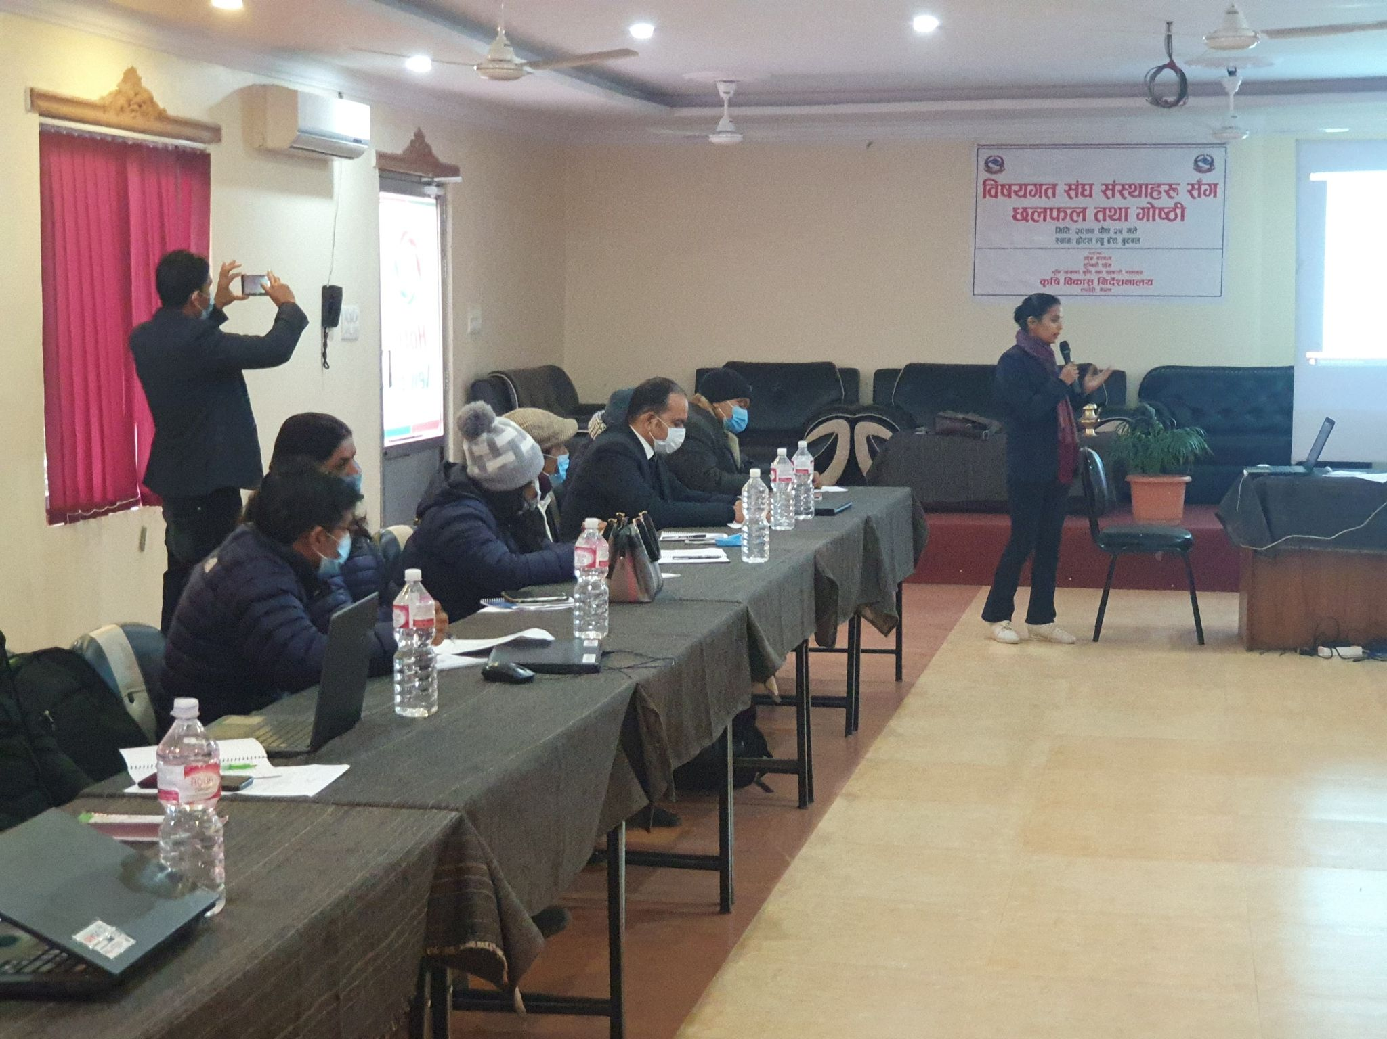

Ms. Kamana Adhikari (Senior Plant protection Officer) presenting DoAD activities in the workshop.

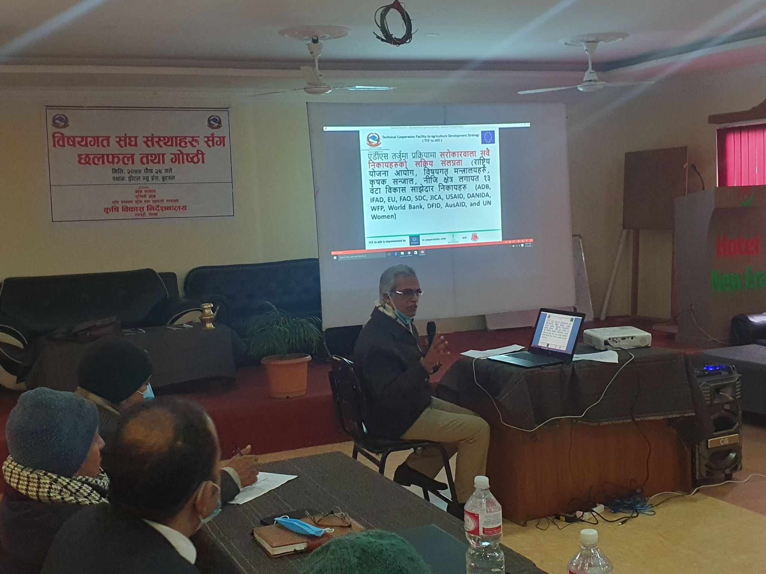

Mr. Dila Ram Bhandari (Provincial ADS expert) presenting ADS orientation slides in the workshop.

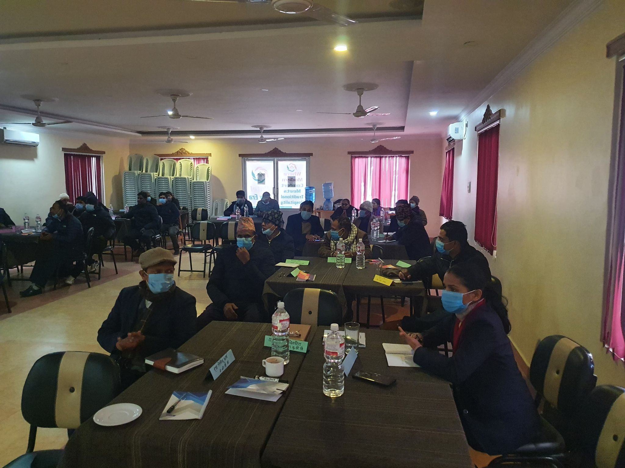
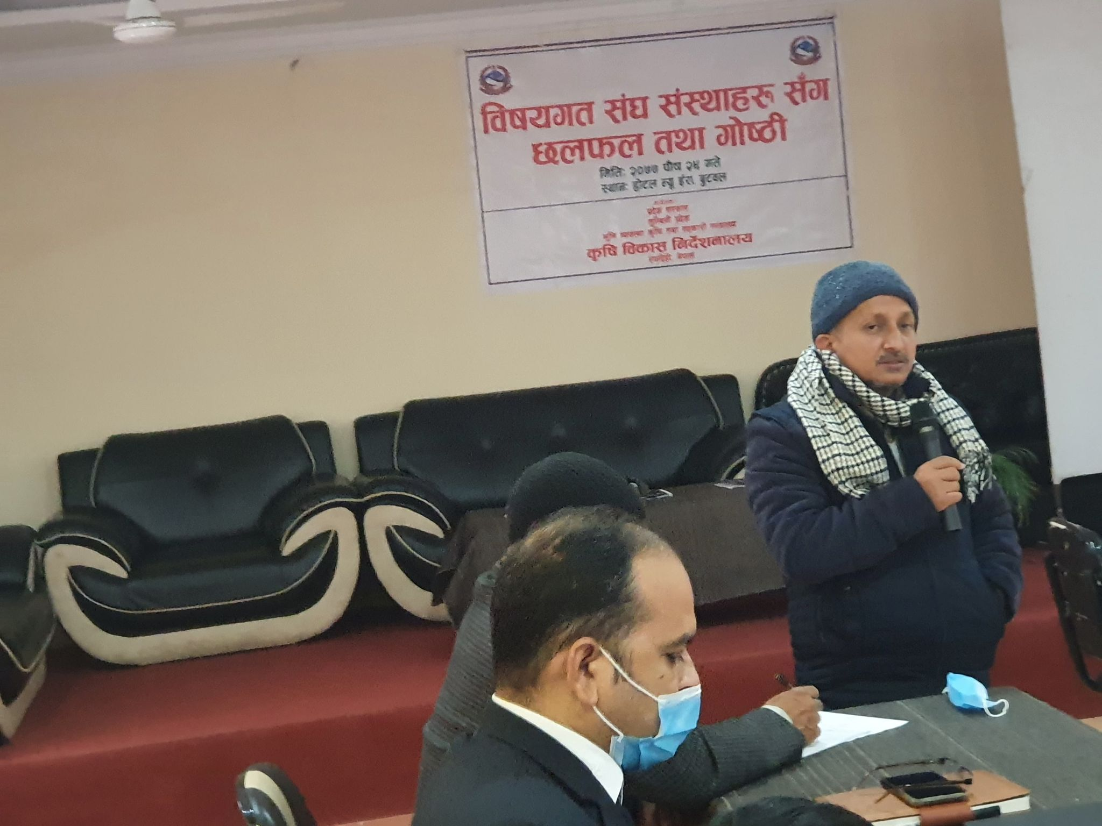
Mr. Yam Narayan Devkota ( Director, DoAD) delivering his closing remarks in the workshop.

